Q1. Develop the following classes and put them in package **shape2d**

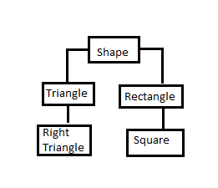

Write test Java program and import the **shape2d package** to test the functioning ofabove classes

**Q2.** Develop the following classes and put them in package **shape3d**

**Solid**

**Cone**

**Sphere**

**Cylinder**

Write test Java program and import the **shape3d package** to test the functioning ofabove classes